**1. GIT CONFIGURATION**

1. To check if Git client is installed properly: Open Git bash shell and execute
2. 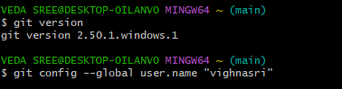user level configuration of user ID and email ID execute
3. 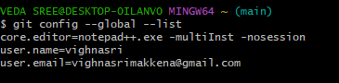check if the configuration is properly set
4. Install notepad++ if not installed and set the path in environment variables
5. After setting environment variables close your previous git bash and open it again
6. Type in git bash notepad++
7. create an alias command for notepad++.exe



1. configure the editor



1. verify if notepad++ is the default editor



1. Open Git bash shell and create a new project “**GitDemo**”



1. 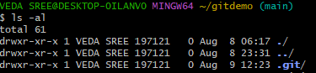 Git bash initializes the “**GitDemo**” repository
2. create a file **“welcome.txt”**



1. to see text in welcome.txt

**cat welcome.txt**

1. check status

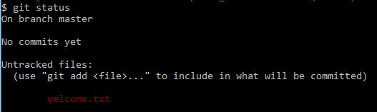git status

1. make the file to be tracked by Git repository
2. add multi line comments, we are opening default editor to comment. Execute the command



1. To check if local and “Working Directory” git repository are same, execute git status



1. Sign up with gitlab and create remote repository “GitDemo”
2. To pull remote repository

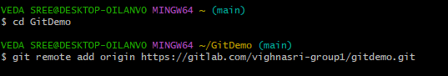

1. 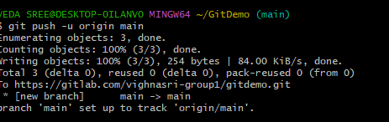To push the local to remote repository